Practical - 3
Practical Title: Responsive UI Design using CSS Grid, Flexbox, and
Bootstrap/Tailwind
Problem Definition: Design responsive layouts for Home, About, Registration, Dashboard, and Events pages using CSS Grid and Flexbox. Optional to use CSS framework such as Bootstrap or Tailwind. Ensure mobile-first responsiveness.
F. Theory
1. How does the layout adapt for mobile, tablet, and desktop screens?
Answer: A layout adapts across mobile, tablet, and desktop screens using fluid grids, flexible images, and breakpoints (typically under 600px for mobile, 601px–1024px for tablets, and 1025px+ for desktops). Elements reflow, resize, or stack vertically to fit the available screen space.
2.Which layout technique is used and why?
Answer: Common web design layout techniques include CSS Flexbox, CSS Grid, and traditional Float or Responsive structures. Because your specific project or graphic was not provided, the correct technique depends entirely on the design goal.
- Are typography, spacing, colors, and contrast readable?
Answer: Yes, typography, spacing, colors, and contrast directly determine whether text is readable. When properly balanced, they prevent eye strain and make content easy to scan. When poorly configured, text becomes difficult or impossible to read.

- Is the framework used consistently without unnecessary inline CSS?
Answer: style="" attributes. While they look like inline styles in the markup, they compile into clean external stylesheets and maintain design consistency without unnecessary true inline CSS.

G. Implementation/ Output/Result :
- CSS Selectors Used:
*, body, header, nav, main, section, article, footer, div, h1, h2, h3, h4, p, ul, li, a, img, form, label, input, textarea, select, button, table, tr, td, hr, small, i, marquee,
.class, #id,
:hover, :focus, :first-child, :last-child, input[type="text"], input[type="email"], input[type="password"], input[type="radio"], input[type="checkbox"], input[type="submit"], input[type="reset"],
@media
- CSS Properties Used:
margin, padding, box-sizing, display, width, height, max-width, background, background-size, background-position, background-repeat, color, font-family, font-size, font-weight, text-align, text-decoration, line-height, border, border-left, border-top, border-radius, box-shadow, position, justify-content, align-items,
flex-direction, flex-wrap, gap, grid-template-columns,
list-style, cursor, transition, transform, outline, resize, object-fit,
overflow
- Evidence of Work (Screenshots)
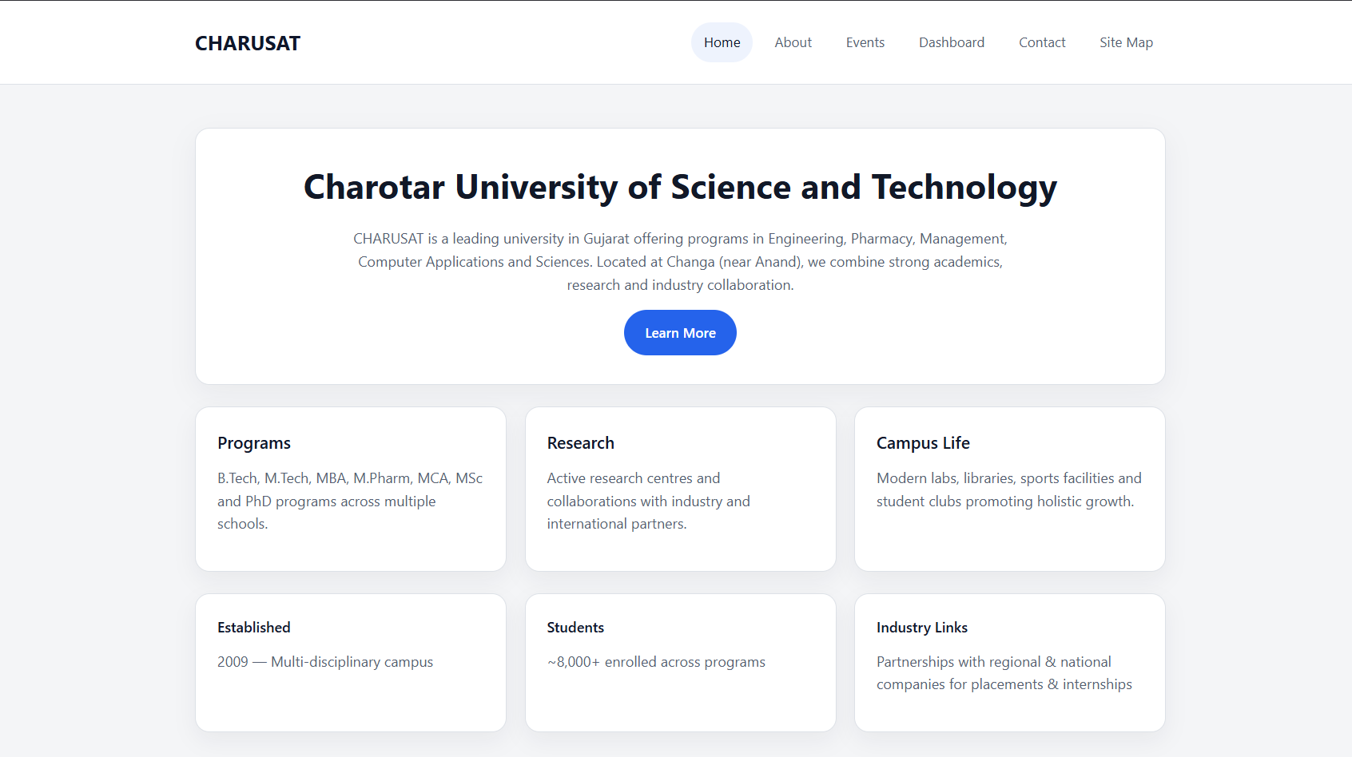
Figure 3.1(Home page)
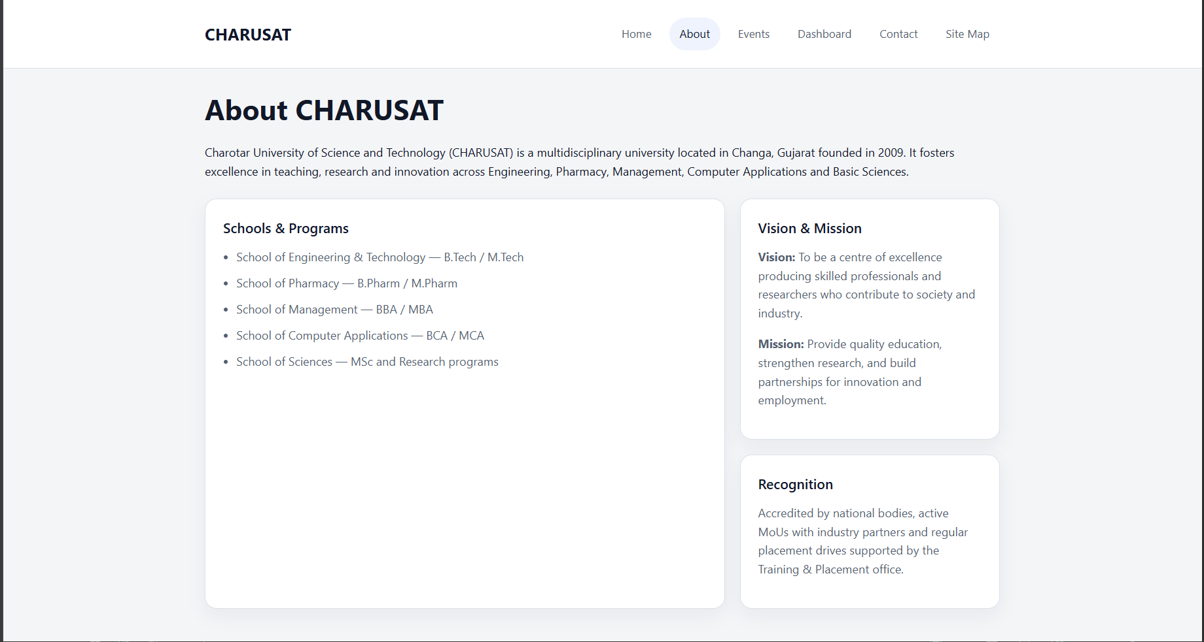
Figure 3.2(About page)
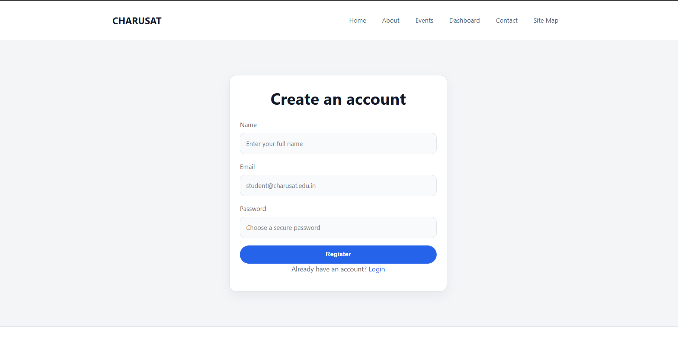
Figure 3.3(Registration page)
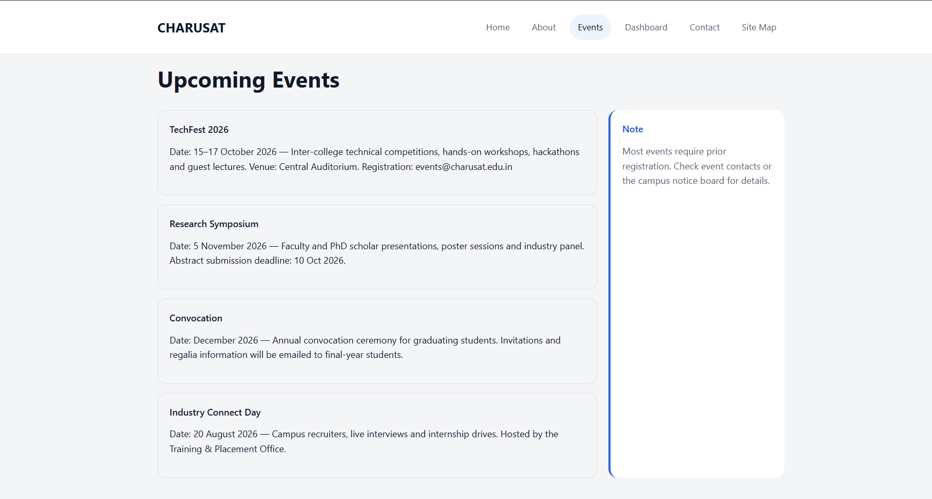
Figure 3.4(Event page)
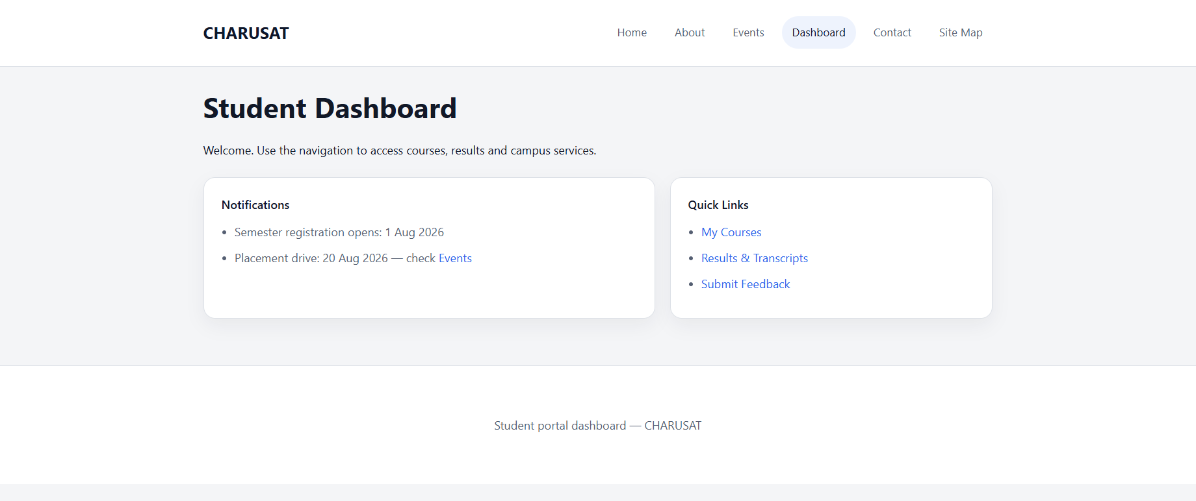
Figure 3.5(Dashboard page)
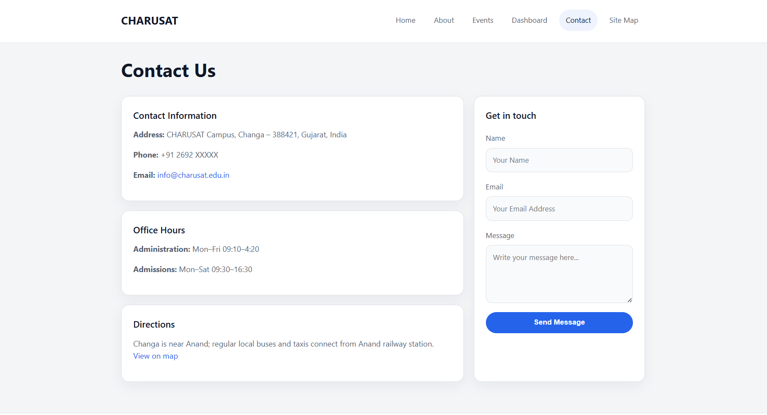
Figure 3.6(Contact)
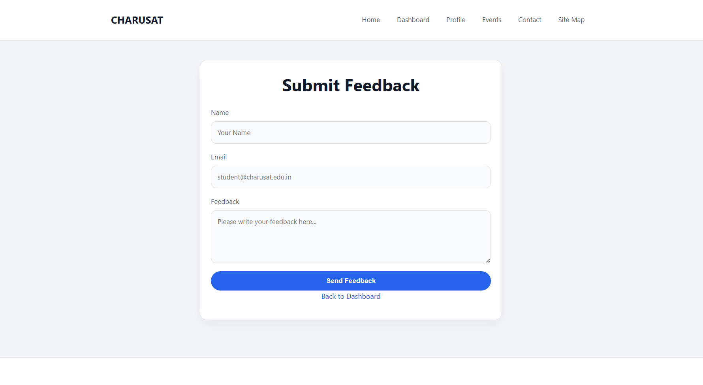
Figure 3.7(FEEDBACK)
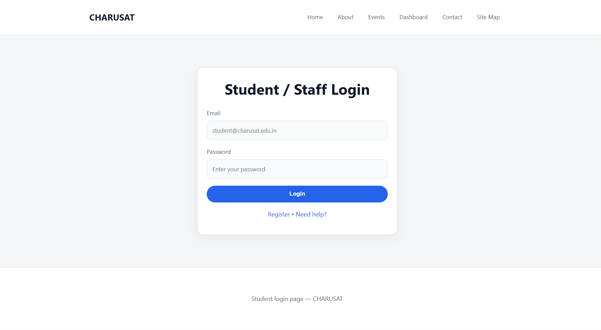

Figure 3.8(Login)

- Repository Link: https://github.com/meet-3834/Student-Hub/tree/main/FINAL%20Submission

- Challenges Faced:

At the Start of practical I have no idea About CSS, so I searched for Basic syntax & references in W3School. I got basic idea what I have to do…then I explain my idea to chatgpt & got syntax from it. Then I searched all elements one by one to undertand use case of it.

- Learning Outcomes:

Now by this Practical I can make basic designs for HTML skeletons using CSS styles, And make website mode attractive & user friendly.

Faculty Remarks: (Keep this blank for faculty)

